1. Write a source code.

2. In the input, enter 2019.

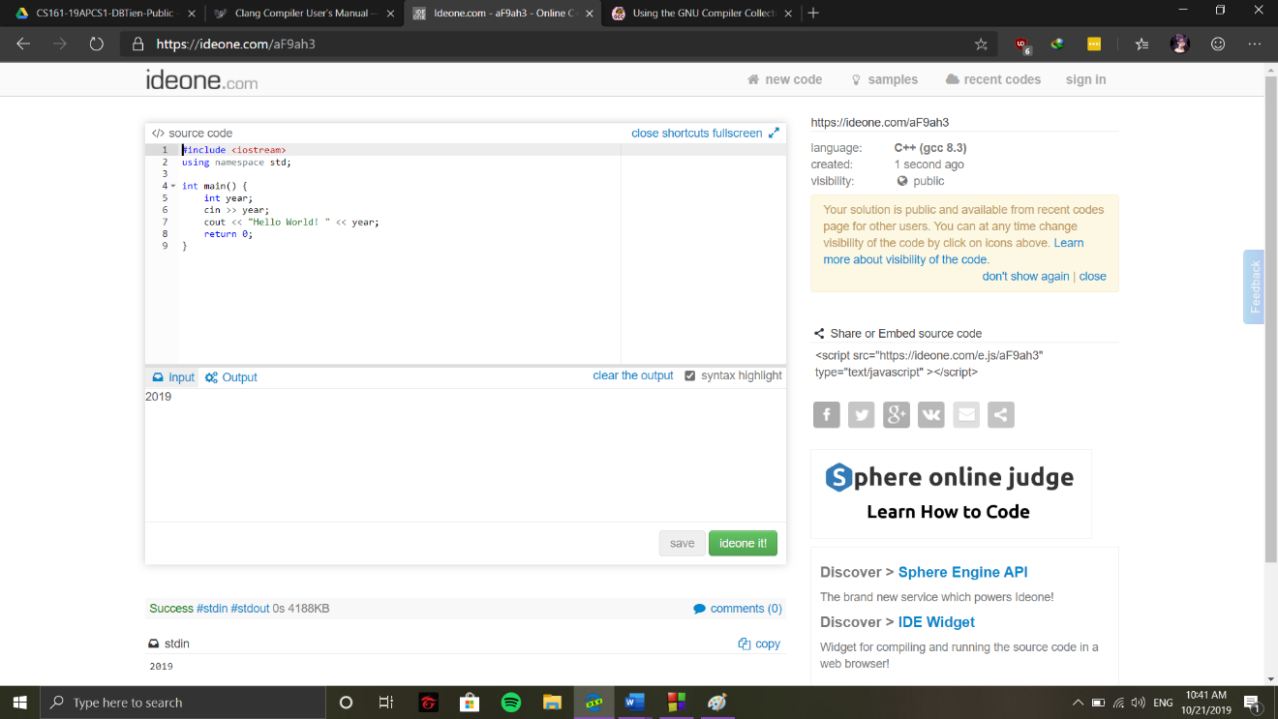3. Ideone it.

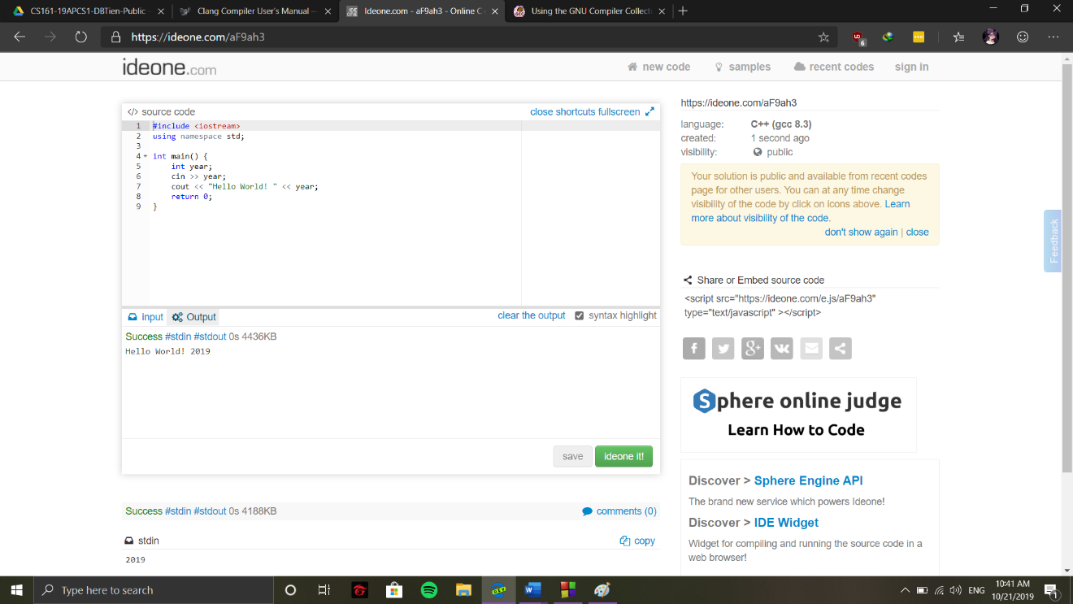Output: Hello World! 2019

Similar websites: <https://www.onlinegdb.com/online_c++_compiler>, <http://cpp.sh/>